Online Food Ordering System
Abstract:
The online food ordering system provides convenience for the customers. It overcomes the disadvantages of the traditional queuing system. This system increases the takeaway of foods than visitors. Therefore, this system enhances the speed and standardization of taking the order from the customer. It provides a better communication platform. The user’s details are noted electronically.
The online food ordering system set up menu online and the customers easily places the order with a simple mouse click. Also with a food menu online you can easily track the orders, maintain customer's database and improve your food delivery service. This system allows the user to select the desired food items from the displayed menu. The user orders the food items. The payment can be made online or pay-on-delivery system. The user’s details are maintained confidential because it maintains a separate account for each user. An id and password is provided for each user. Therefore it provides a more secured ordering.

Introduction
My motivation for creating this app stemmed from the fact that my family works in the fast food industry, and I dislike waiting in lines or having to call ahead to place an order, especially during peak lunch or dinner hours. The technology we recommend is an easy-to-use online meal ordering system for customers. It overcomes the disadvantages of traditional queueing systems. Our system is both a convenient way to order food from restaurants and a mess service. The procedure of taking a customer's order is made easier with this technology. Customers may place orders fast utilising the online meal ordering system, which generates an online menu. Customers can also use a meal menu to keep track of their orders. Users can also rate the food goods using this system's feedback feature. In addition, based on the user's ratings, the proposed system can recommend hotels and meals, and the hotel staff will be notified of any quality adjustments.

Literature Survey
Given below are the research papers used for our analysis whilst considering various approaches.
In [4] along with customer feedback for a restaurant a design and execution of wireless food ordering system was carried out. It enables restaurant owners to setup the system in wireless environment and update menu presentations easily. Smart phone has been integrated in the customizable wireless food ordering system with real- time customer feedback implementation to facilitate real- time communication between restaurant owners and customers.
In Paper [5], the purpose of this study was to investigate the factors that influence the attitude of internet users towards online food ordering in Turkey among university students. A Technology Acceptance Model (TAM) developed by Davis in 1986 was used to study adoption of Web environment for food ordering. Trust, Innovativeness and External Influences are added to the model as main factors along with TAM.
In Paper [6], the research work aims to automate the food ordering process in restaurant and also improve the dining experience of customers. Design implementation of food ordering system for restaurants were discuss in this paper. This system implements wireless data access to servers. The android application on user’s mobile will have all the menu details. Kitchen and cashier receive the order details from the customer mobile wirelessly. These order details are updated in the central database. The restaurant owner can manage the menu modifications easily.

Existing System
In existing system for giving any orders users should visit hotels or restaurants to know about food items and them give order and pay advance. In this method time and manual work is required. Maintaining critical information in the files and manuals is full of risk and a tedious process.
Drawbacks
- Its Manual Process so its not accurate and fast
- Customers need to order food
- Manually maintain the reports and sales
Proposed System
This online application enables the end users to register online, select the food from the e-menu card, read the E-menu card and order food online. By just selecting the food that the user want to have. The results after selecting the food from the E-menu card will directly appear in the screen near the Chef who is going to cook the food for you. By using this application the work of the Waiter is reduced and we can also say that the work is nullified. The benefit of this is that if there is rush in the Restaurant then there will be chances that the waiters will be unavailable and the users can directly order the food to the chef online by using this application. The user will be given a username and a password to login.

Advantages
- Automated Business process- records management, payment transaction, and report generation is much easier and convenient to process
- Records Management – it is a database system that makes the records electronic, safe, accurate, reliable, and fast.
- Report Generation – the system automatically generates and provides real-time reports on the status of the inquired repair services.

Modules
Admin
The person in this module has control over the entire system as he/she can add, delete anyone from the system. The admin can view the details of another person and can edit any details. The users from another module will send the request to admin for any change.
Restaurant
Those who provides food , he can register and login into the system, He can check the orders and reviews.
Customer
Customer can order the food through this website. Customer need to register and login into the system. He can give the feedback also.

Hardware Configuration
- Processor Intel I3 Processor
- RAM 4 GB
- Monitor 15 inch color monitor or LED
- Hard disk 160 GB
- Key board Standard 102 keys
- Mouse Optical
Software Configuration
- Operating system Windows
- IDE PyCharm
- Language Python
- Framework Django
- Back End MYSQL
- Front End HTML,CSS,JS,Bootstrap
- Server Apache Tomcat

Scope and Objective of the Project
The main objective of the food order system is to provide food on time.
The scope of the project is that can be used by any user through web and can access the application
Feasibility Study
A significant result of starter examination is the assurance that the framework solicitation is attainable. “The possibility of the venture is broke down in this stage and strategic agreement is advanced with a general arrangement for the task and some cost evaluations. During framework investigation the attainability investigation of the proposed framework is to be done. This is to guarantee that the proposed framework isn't a weight to the organization. For attainability investigation, some comprehension of the significant necessities for the framework is essential”. This is conceivable just in the event that it is practical inside restricted asset and time. The prime feasibility considerations are:

Technical feasibility:
This examination is done to check the specialized practicality, that is, the specialized necessities of the framework. “Any framework created must not have an intense interest on the accessible specialized assets. This will prompt levels of popularity on the accessible specialized assets. This will prompt levels of popularity being put on the customer. The created framework must have a humble necessity, as just negligible or invalid changes are required for actualizing this framework”.

Economical feasibility:
This investigation is done to check the financial effect that the framework will have on the association. “The measure of reserve that the organization can fill the innovative work of the framework is restricted. The uses must be defended. In this manner the created framework also inside the spending limit and this was accomplished in light of the fact that the vast majority of the innovations utilized are openly accessible. Just the modified items must be bought”.

Social feasibility:
The part of study is to check the degree of acknowledgment of the framework by the client. “This incorporates the way toward preparing the client to utilize the framework productively. The client must not feel undermined by the framework, rather should acknowledge it as a need. The degree of acknowledgment by the clients exclusively relies upon the strategies that are utilized to instruct the client about the framework and to make him acquainted with it. His degree of certainty must be raised with the goal that he is additionally ready to make some useful analysis, which is invited, as he is the last client of the framework”.

Operational feasibility:
This area of feasibility makes sure that the project satisfies all the requirements that were discusses during initial requirement analysis phase. Our project met all the requirements proposed earlier. It made sure that the modules discussed during the proposing of the system were implemented with stable accuracy and without any errors.
Process Model - WATERFALL MODEL
Waterfall model indicates that all the SDLC steps will be going on step by step. In this model once one stage completed then only it will start the another process. This will be implemented when the requirements well known and clearly defined.
In this model we can implement all the setps one by one. First we will do requirements gathering i.e in this step business analyst will collect the all functional requirements from the client and will discuss with the manager and development team. Second step is analysis where people can analyses the requirements so that they will do risk basement, risk mitigation, risk controlling steps. And also they will do the cost-time analysis to estimate the cost. They will also do the detail feasible study over the requirements of project.
In third phase called design page generally people will design the project i.e represent will prepare the uml diagrams and prototypes for project. And then developers will start programing or coding based on design . Finally testing team will test the content to identify and fix the bugs. After successful user acceptance testing application will be deployed and maintained in the client machine.

The waterfall model was selected as the SDLC model due to the following reasons:
- When the requirements are very clear and not changed.
- Available technology is enough to implement.
- Project is easy and simple to understand to finish.
- And if we don’t have any confusion in requirements.
- We can easily manage the review process and task management.
- Every stage defined clearly and with timelines

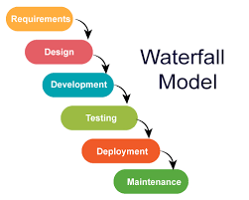

INPUT DESIGN
The input design is the link between the information system and the user. It comprises the developing specification and procedures for data preparation and those steps are necessary to put transaction data in to a usable form for processing can be achieved by inspecting the computer to read data from a written or printed document or it can occur by having people keying the data directly into the system. The design of input focuses on controlling the amount of input required, controlling the errors, avoiding delay, avoiding extra steps and keeping the process simple. The input is designed in such a way so that it provides security and ease of use with retaining the privacy. Input Design considered the following things:
- What data should be given as input?
- How the data should be arranged or coded?
- The dialog to guide the operating personnel in providing input.
- Methods for preparing input validations and steps to follow when error occur.

OBJECTIVES
1.Input Design is the process of converting a user-oriented description of the input into a computer-based system. This design is important to avoid errors in the data input process and show the correct direction to the management for getting correct information from the computerized system.
2. It is achieved by creating user-friendly screens for the data entry to handle large volume of data. The goal of designing input is to make data entry easier and to be free from errors. The data entry screen is designed in such a way that all the data manipulates can be performed. It also provides record viewing facilities.
3.When the data is entered it will check for its validity. Data can be entered with the help of screens. Appropriate messages are provided as when needed so that the user will not be in maize of instant. Thus the objective of input design is to create an input layout that is easy to follow

OUTPUT DESIGN
A quality output is one, which meets the requirements of the end user and presents the information clearly. In any system results of processing are communicated to the users and to other system through outputs. In output design it is determined how the information is to be displaced for immediate need and also the hard copy output. It is the most important and direct source information to the user. Efficient and intelligent output design improves the system’s relationship to help user decision-making.
1. Designing computer output should proceed in an organized, well thought out manner; the right output must be developed while ensuring that each output element is designed so that people will find the system can use easily and effectively. When analysis design computer output, they should Identify the specific output that is needed to meet the requirements.
2.Select methods for presenting information.
3.Create document, report, or other formats that contain information produced by the system.
The output form of an information system should accomplish one or more of the following objectives.
- Convey information about past activities, current status or projections of the
- Future.
- Signal important events, opportunities, problems, or warnings.
- Trigger an action.
- Confirm an action.

SYSTEM MODEL

This section consists of the UML diagrams related to the modules developed such as Activity diagram, Sequence diagram and Use case diagram.
UML stands for Unified Modeling Language. UML is a standardized general-purpose modeling language in the field of object-oriented software engineering. The standard is managed, and was created by, the Object Management Group.
The goal is for UML to become a common language for creating models of object oriented computer software. In its current form UML is comprised of two major components: a Meta-model and a notation. In the future, some form of method or process may also be added to; or associated with, UML.
The Unified Modeling Language is a standard language for specifying, Visualization, Constructing and documenting the artifacts of software system, as well as for business modeling and other non-software systems.
The UML represents a collection of best engineering practices that have proven successful in the modeling of large and complex systems.
The UML is a very important part of developing objects oriented software and the software development process. The UML uses mostly graphical notations to express the design of software projects.

GOALS:
The Primary goals in the design of the UML are as follows:
- Provide users a ready-to-use, expressive visual modeling Language so that they can develop and exchange meaningful models.
- Provide extendibility and specialization mechanisms to extend the core concepts.
- Be independent of particular programming languages and development process.
- Provide a formal basis for understanding the modeling language.
- Encourage the growth of OO tools market.
- Support higher level development concepts such as collaborations, frameworks, patterns and components.
- Integrate best practices.
- Sequence Diagram
- A grouping outline in UML is a sort of association chart that shows how procedures work with each other and in what request. “It is a build of a Message Sequence Chart. Succession outlines are now and again called occasion charts, occasion situations, and timing graphs”.
- Admin-Sequence Diagram:
- 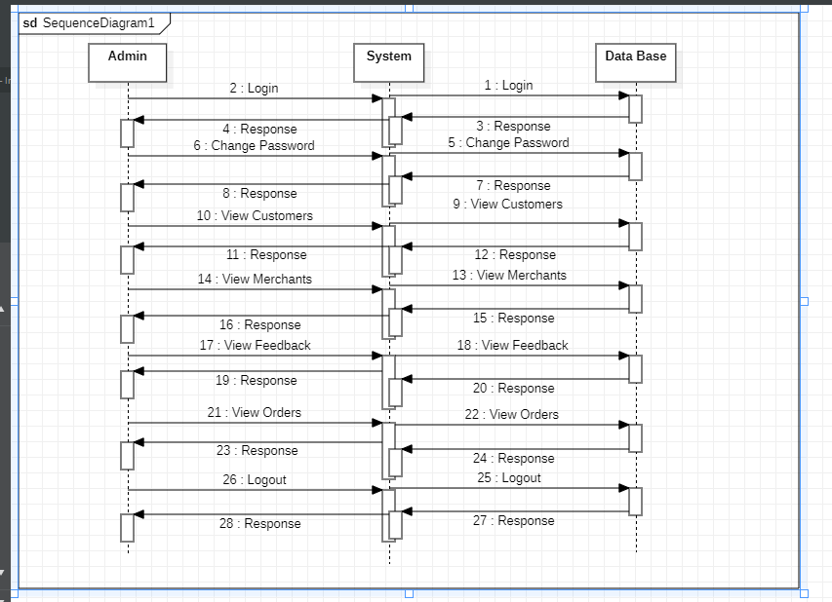

- Merchant-Sequence Diagram:
- 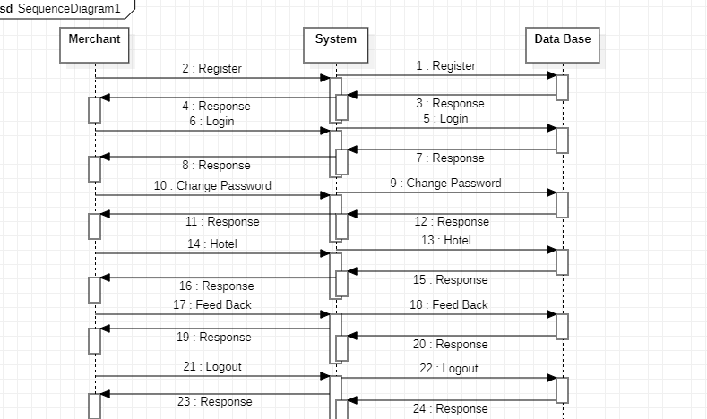

- Customer-Sequence Diagram:
- 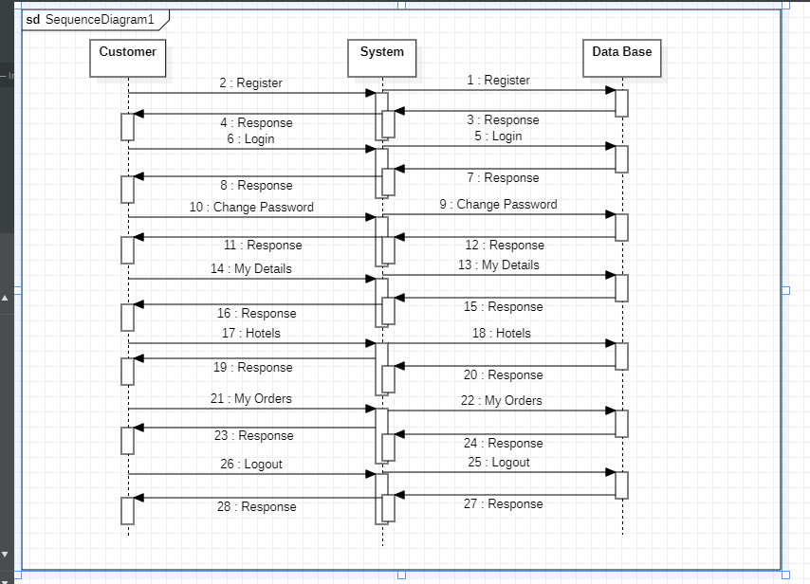

- Use Case Diagram
- An utilization case outline in the UML is a sort of conduct graph characterized by and made from a Use-case examination. Its motivation is to introduce a graphical diagram of the usefulness given by a framework regarding on-screen characters, their objectives (spoke to as use cases), and any conditions between those utilization cases. The fundamental motivation behind an utilization case outline is to indicate what framework capacities are performed for which on-screen character. Jobs of the on-screen characters in the framework can be delineated”.
- Admin-Use Case Diagram:
- 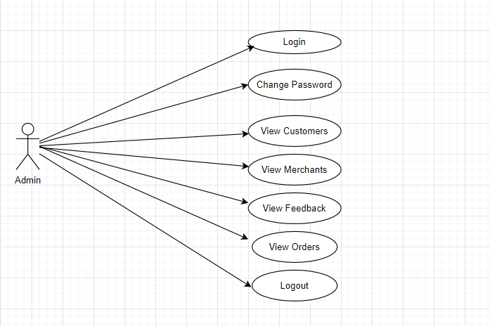

- Merchant-Use Case Diagram:
- 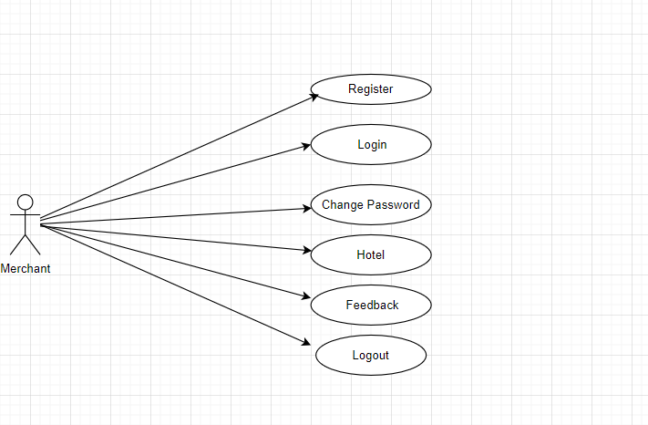

- Customer-Use Case Diagram:
- 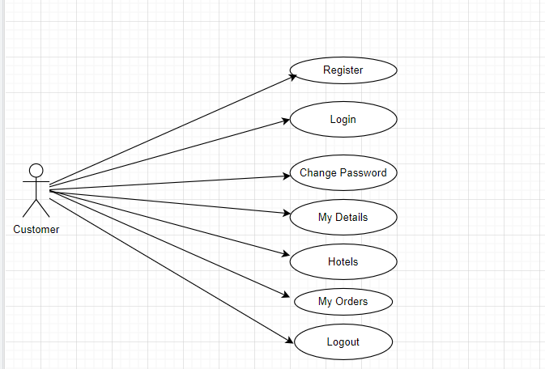

- Activity Diagram
- “Movement charts are graphical portrayals of work processes of stepwise exercises and activities with help for decision, emphasis and simultaneousness. In the Unified Modeling Language, movement graphs can be utilized to depict the business and operational bit by bit work processes of parts in a framework. A movement chart demonstrates the general progression of control”.
- Admin-Activity Diagram:
- 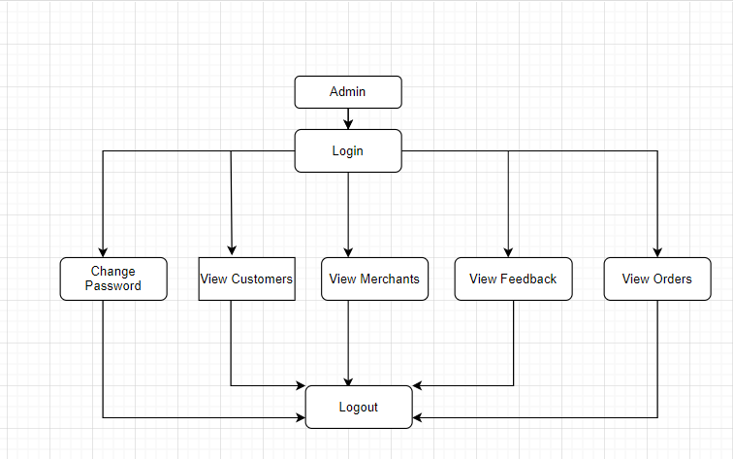
- Merchant-Activity Diagram:
- 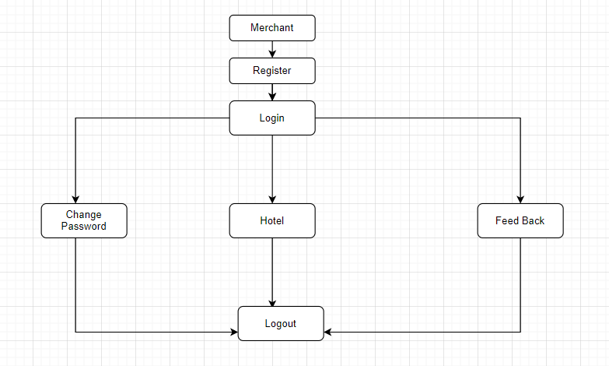
- Customer-Activity Diagram:
- 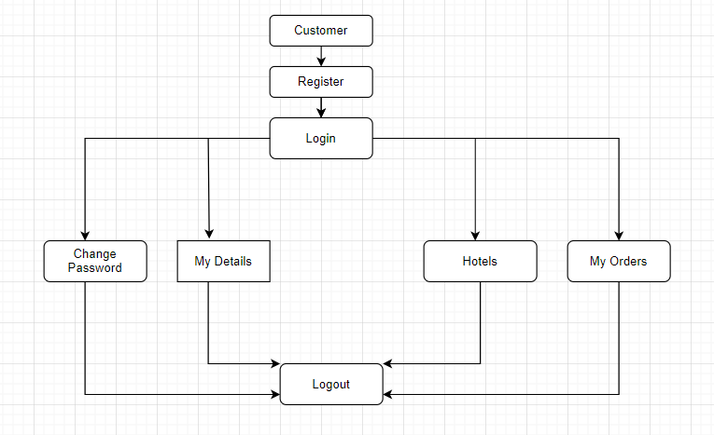

- Component Diagram
- The component diagram is a special purpose diagram, which is used to visualize the static implementation view of a system. It represents the physical components of a system, or we can say it portrays the organization of the components inside a system. The components, such as libraries, files, executables, etc.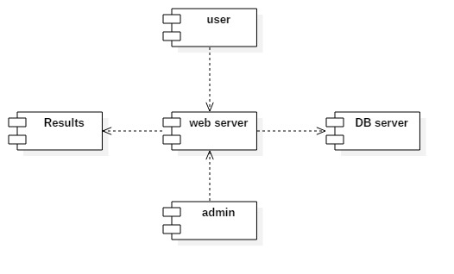
- Deployment Diagram
- A deployment diagram is a UML diagram type that shows the execution architecture of a system, including nodes such as hardware or software execution environments, and the middleware connecting them. Deployment diagrams are typically used to visualize the physical hardware and software of a system
- 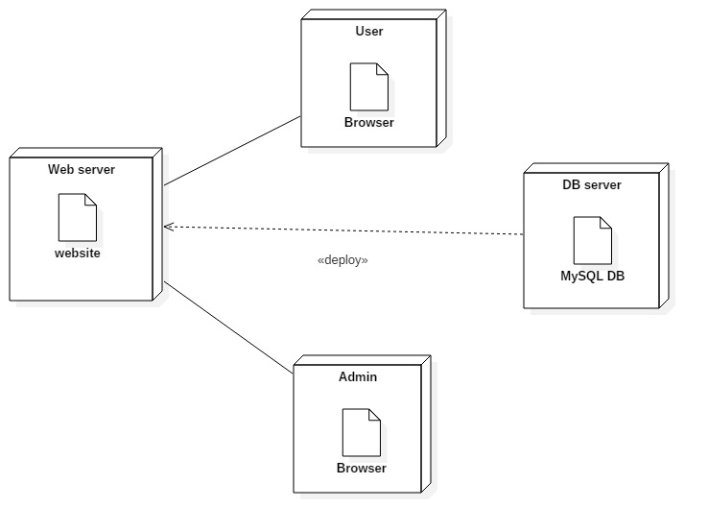
- Class Diagram:
- Class diagram is a static diagram. It represents the static view of an application. Class diagram is not only used for visualizing, describing, and documenting different aspects of a system but also for constructing executable code of the software application.
- Class diagram describes the attributes and operations of a class and also the constraints imposed on the system. The class diagrams are widely used in the modeling of object oriented systems because they are the only UML diagrams, which can be mapped directly with object-oriented languages.
- 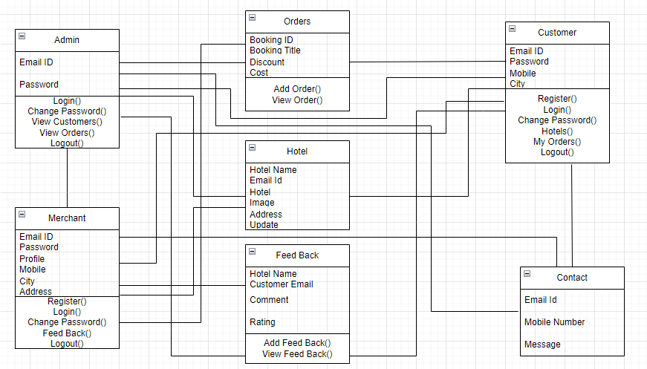

- ER Diagram
- An Entity Relationship (ER) Diagram is a type of flowchart that illustrates how “entities” such as people, objects or concepts relate to each other within a system. ER Diagrams are most often used to design or debug relational databases in the fields of software engineering, business information systems, education and research. Also known as ERDs or ER Models, they use a defined set of symbols such as rectangles, diamonds, ovals and connecting lines to depict the interconnectedness of entities, relationships and their attributes. They mirror grammatical structure, with entities as nouns and relationships as verbs.
- 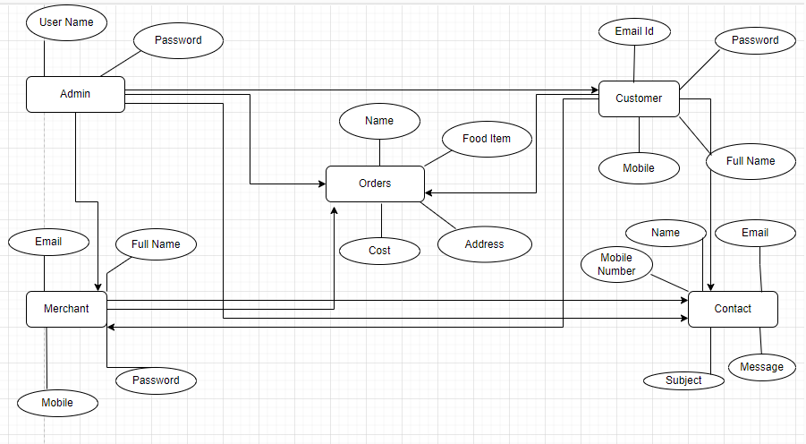

- Data Flow Diagram
- A data-flow diagram is a way of representing a flow of data through a process or a system. The DFD also provides information about the outputs and inputs of each entity and the process itself. A data-flow diagram has no control flow — there are no decision rules and no loops. A data flow diagram (DFD) maps out the flow of information for any process or system. It uses defined symbols like rectangles, circles and arrows,

- 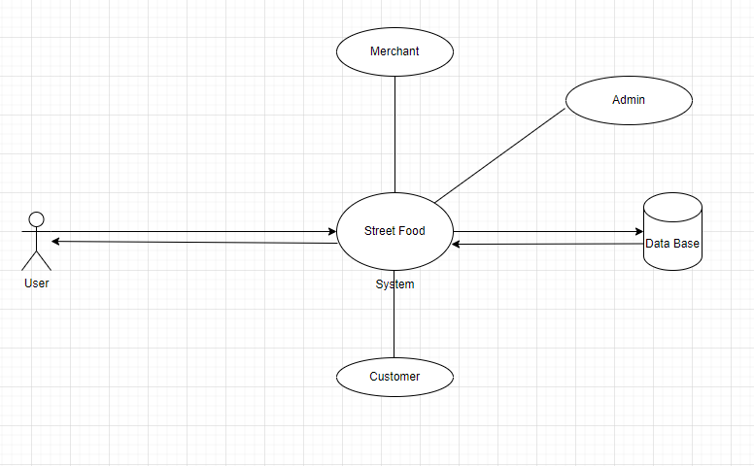

Implementation
PYTHON
Python is a general-purpose interpreted, interactive, object-oriented, and high-level programming language. An interpreted language, Python has a design philosophy that emphasizes code readability (notably using whitespace indentation to delimit code blocks rather than curly brackets or keywords), and a syntax that allows programmers to express concepts in fewer lines of code than might be used in languages such as C++or Java. It provides constructs that enable clear programming on both small and large scales. Python interpreters are available for many operating systems. CPython, the reference implementation of Python, is open source software and has a community-based development model, as do nearly all of its variant implementations. CPython is managed by the non-profit Python Software Foundation. Python features a dynamic type system and automatic memory management. It supports multiple programming paradigms, including object-oriented, imperative, functional and procedural, and has a large and comprehensive standard library
DJANGO
Django is a high-level Python Web framework that encourages rapid development and clean, pragmatic design. Built by experienced developers, it takes care of much of the hassle of Web development, so you can focus on writing your app without needing to reinvent the wheel. It’s free and open source.
Django's primary goal is to ease the creation of complex, database-driven websites. Django emphasizes reusabilityand "pluggability" of components, rapid development, and the principle of don't repeat yourself. Python is used throughout, even for settings files and data models.
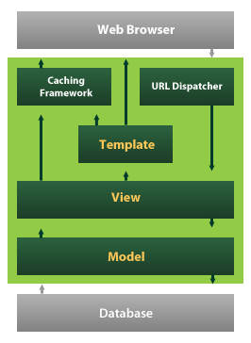
Django also provides an optional administrative create, read, update and delete interface that is generated dynamically through introspection and configured via admin models

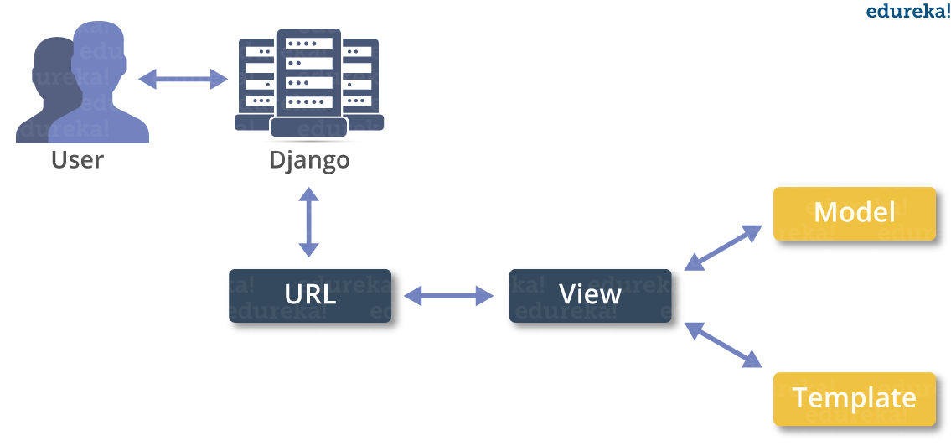

About Technology - Python
“Python can be utilized to make applications which can be utilized inside an Enterprise or an Organization. Some constant applications are: OpenErp, Tryton, Picalo and so on”.

There are a few such applications which can be created utilizing Python

Installation on Windows
“Visit the link https://www.python.org/downloads/ to download the latest release of Python. In this process, we will install Python 3.6.7 on our Windows operating system”.

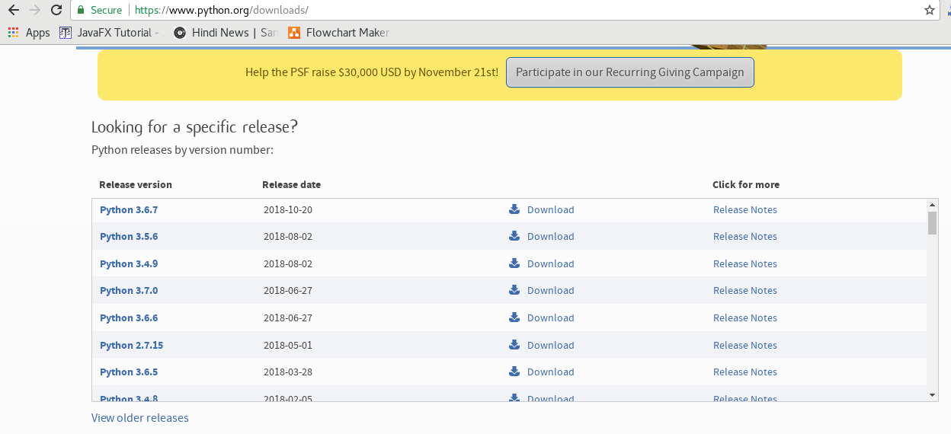
Double tap the executable document which is downloaded; the accompanying window will open. Select Customize establishment and continue.
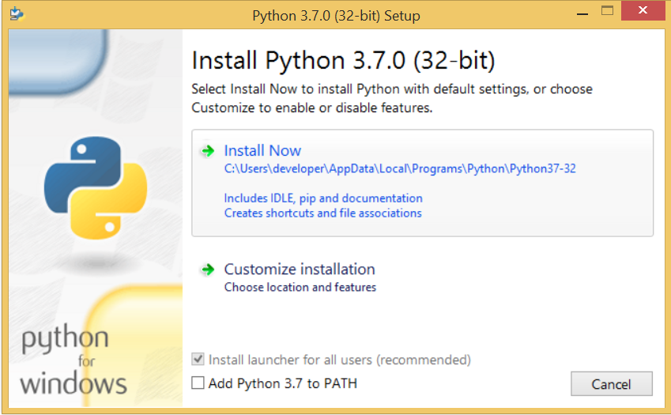
The accompanying window demonstrates all the discretionary highlights. Every one of the highlights should be introduced and are checked as a matter of course; we have to click beside proceed.
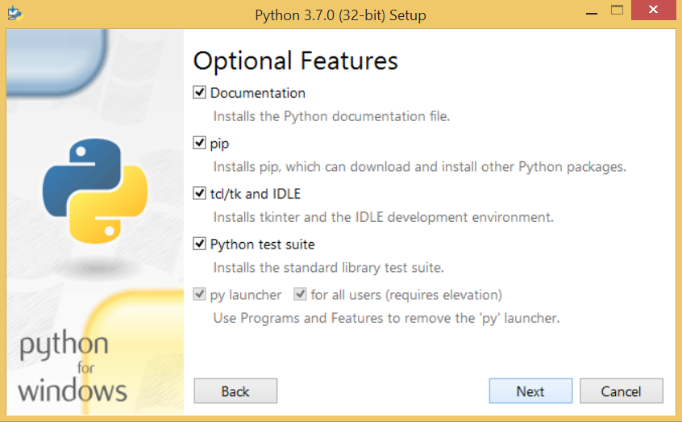
The accompanying window demonstrates a rundown of cutting edge choices. Check every one of the choices which you need to introduce and click straightaway. Here, we should see that the main registration (introduce for all clients) must be checked.
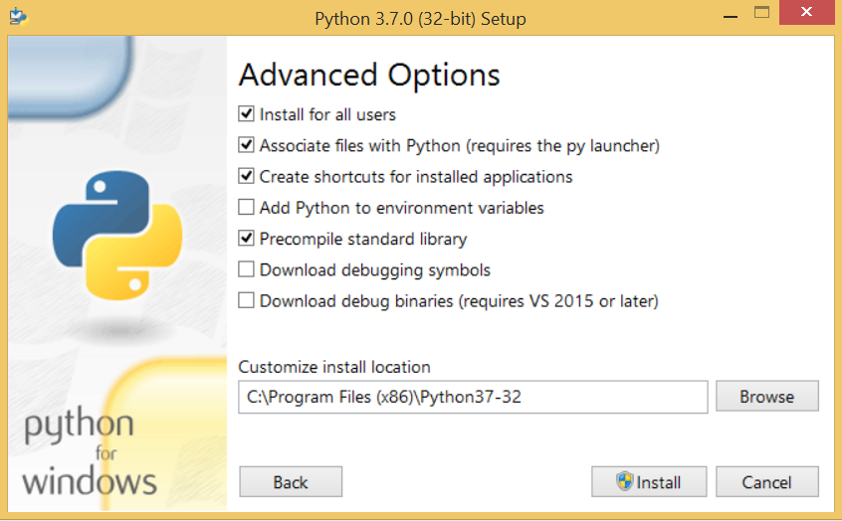
Now, we are ready to install python-3.6.7. Let's install it.
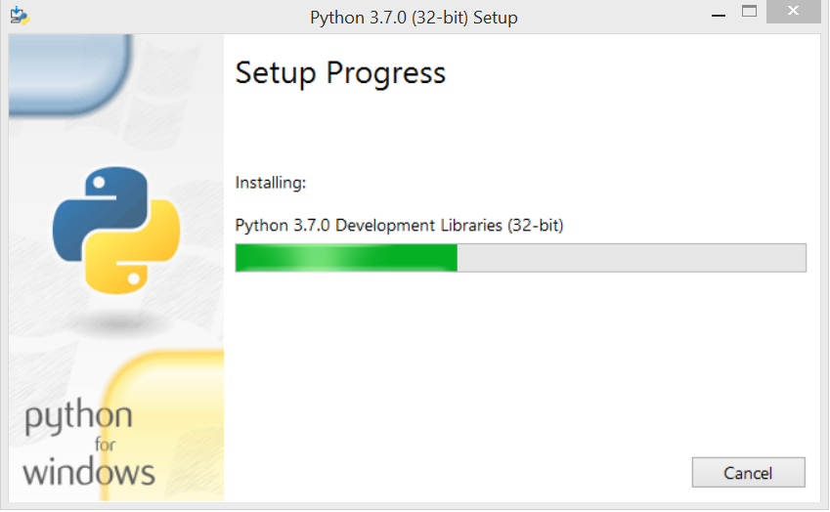
Now, “try to run python on the command prompt. Type the command python in case of python2 or python3 in case of python3. It will show an error as given in the below image. It is because we haven't set the path”.
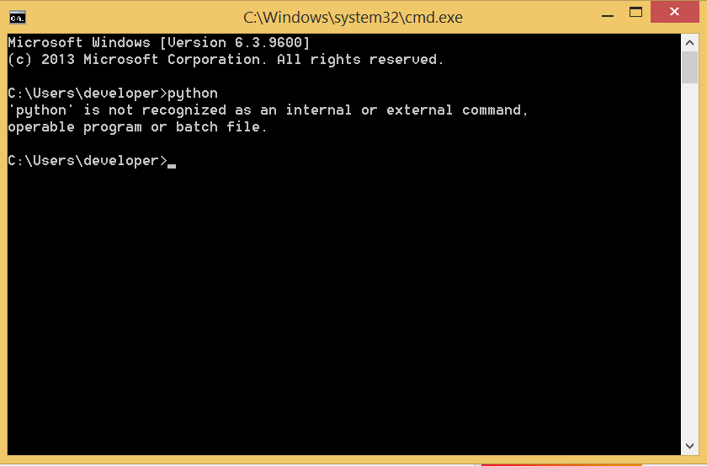
To set the path of python, we need to the right click on "my computer" and go to Properties → Advanced → Environment Variables.
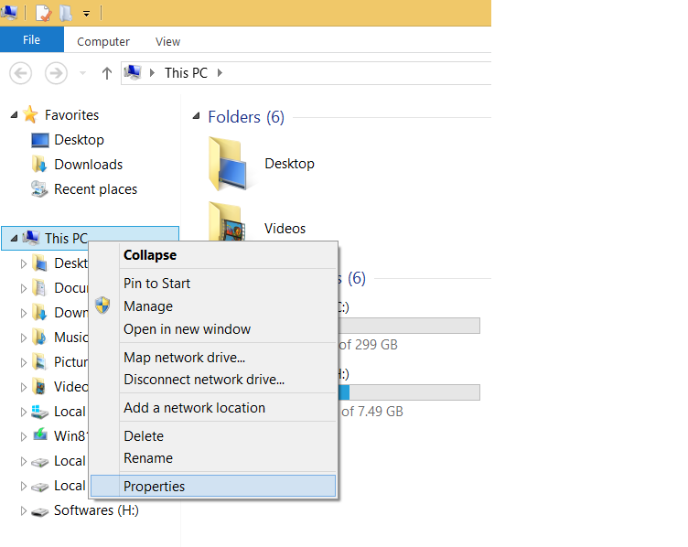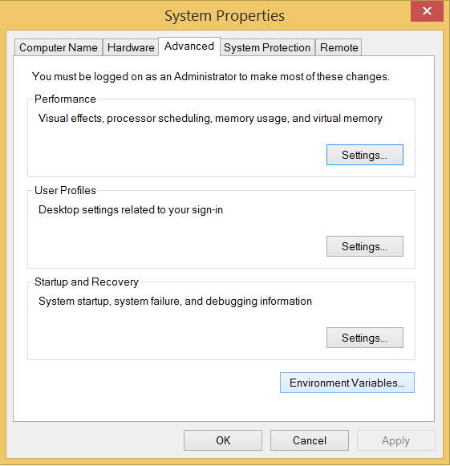
Add the new path variable in the user variable section.
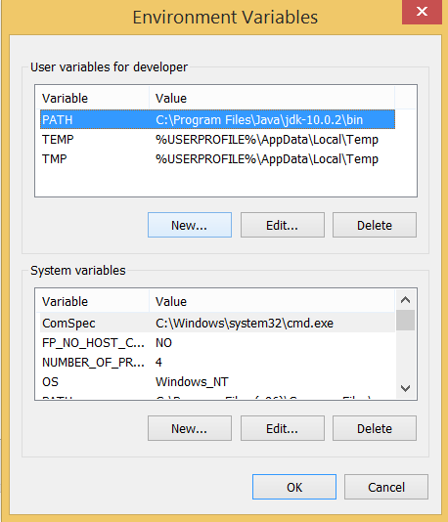
Type PATH as the variable name and set the way to the establishment catalog of the python appeared in the underneath picture.
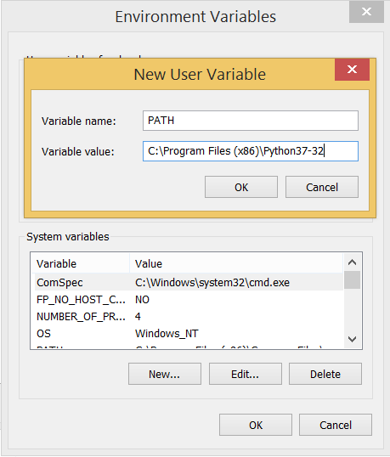
Presently, the way is set, “we are prepared to run python on our nearby framework. Restart CMD, and type python once more. It will open the python mediator shell where we can execute the python proclamations”.

Libraries Used:
Scikit-Learn
Scikit-learn is a free software machine learning library for the Python programming language. It features various classification, regression and clustering algorithms including support vector machines,

NumPy:
NumPy stands for ‘Numerical-Python’ or ‘Numeric-Python’. It is often pronounced as num-pai or num-pee. It is a library for the Python programming language mainly used for interacting with multidimensional and large arrays and matrices. It has a large number of built in mathematical functions which can be used on the large arrays for analyzing them. It is a very good package that can be used on any mathematical and statistics related operation. It works well with multi-dimensional array, data science programming, linear-algebra, random number problems, Fourier-transform etc. This library is more efficient in terms of memory and can manage large amount of data than any other library.

Pandas:
Pandas is also a library used for dealing with data in data science. Apart from Numpy which deals with multi-dimensional arrays, Pandas deals with data in tabular form i.e. data in the form of rows and columns. In this library a 1D array called as Series, a 2D-table called as Data Frames and the combination of Data Frames called as Panel objects are used. We can edit the Series by adding or deleting elements into the array like objects. We can even add, delete or edit the rows and columns in the Data Frame. In similar lines with Numpy, Pandas also provides the primary mathematical operations such as adding subtracting, conditional-operations and even broadcasting.
Matplotlib
Matplotlib produces publication-quality figures in a variety of hardcopy formats and interactive environments across platforms. Matplotlib can be used in Python scripts, the Python and IPython shell, web application servers, and various graphical user interface toolkits.
PIL
Python Imaging Library is a free and open-source additional library for the Python programming language that adds support for opening, manipulating, and saving many different image file formats. It is available for Windows, Mac OS X and Linux.
PYCHARM installation

Steps Involved
You will have to follow the steps given below to install PyCharm on your system. These steps show the installation procedure starting from downloading the PyCharm package from its official website to creating a new project.

Step 1
Download the required package or executable from the official website of PyCharm https://www.jetbrains.com/pycharm/download/#section=windowsHere you will observe two versions of package for Windows as shown in the screenshot given below −
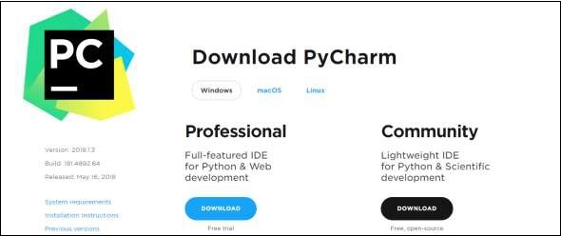
Note that the professional package involves all the advanced features and comes with free trial for few days and the user has to buy a licensed key for activation beyond the trial period. Community package is for free and can be downloaded and installed as and when required. It includes all the basic features needed for installation. Note that we will continue with community package throughout this tutorial.

Step 2
Download the community package (executable file) onto your system and mention a destination folder as shown below −
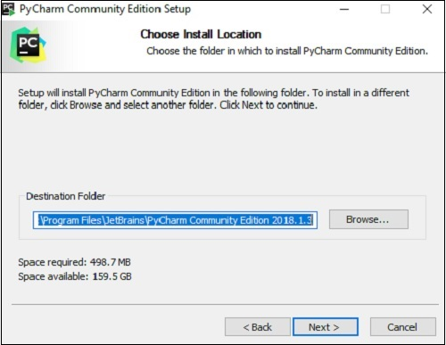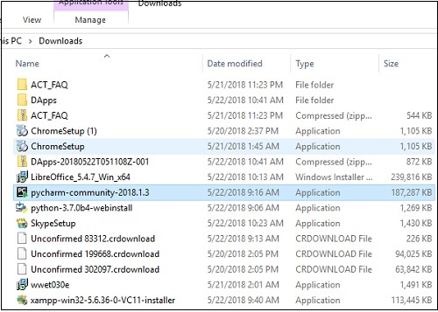

Step 3
Now, begin the installation procedure similar to any other software package.
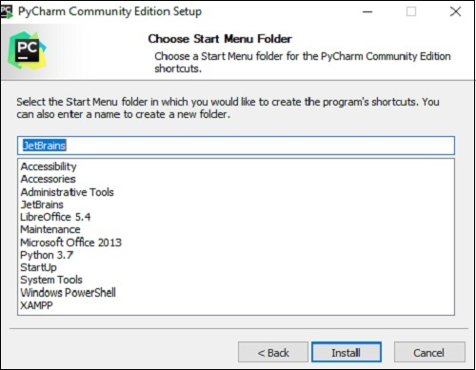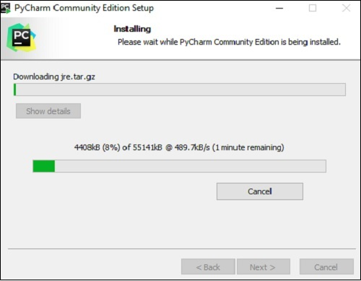

Step 4
Once the installation is successful, PyCharm asks you to import settings of the existing package if any.
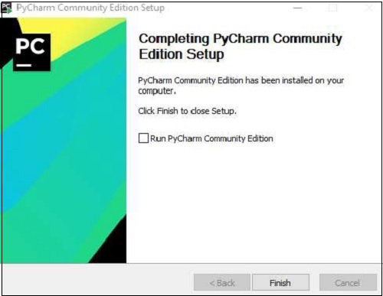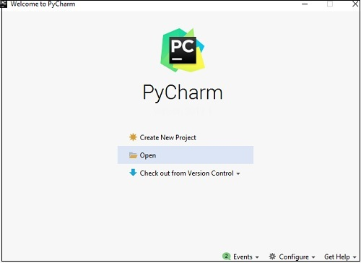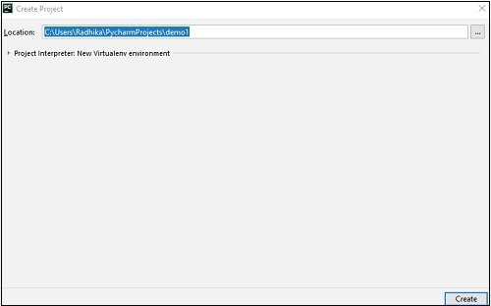
This helps in creating a new project of Python where you can work from the scratch. Note that unlike other IDEs, PyCharm only focusses on working with projects of Python scripting language.

HTML:
Html is used to design the static web pages on web development. Static web page is that kind of web page, in which all the information and material is presented before users as it is exactly stored. Dynamic web page is web page where user can control the operations on website. Html is markup language to develop the web pages. It is basic web technology in web designing and which is used to develop the applications.
Html provides two types of content like input elements which are used to read the input from the user and semantic elements are used to display the data. We have different types of data elements to display the data and working on website.Html have different versions to manage the data efficiently.

CSS:
CSS is a cascading style sheet which will help you to style the webpage . we can apply the effects, styles, font-sizes , animations and others styles to web page. By using css3 we can develop the responsive web pages and we can develop the responsive website. Responsive website can open in the both mobile and browsers effectively.
It is mainly used to apply the color and effects more visibly to the webpage. It is attribute based language and which contains many attribute and value pairs to apply as styles. Css has three versions to apply the styles. It also have different framework like w3.css bootstrap to simplify the css style application.
CSS handles the seem and experience section of a internet page. Using CSS, you can manage the coloration of the text, the fashion of fonts, the spacing between paragraphs, how columns are sized and laid out, what heritage snap shots or colours are used, format designs, versions in show for extraordinary units and display sizes as properly as a range of different effects.CSS is convenient to analyze and recognize however it presents effective manipulate over the presentation of an HTML document.Define fashion sheet regulations immediately along-with the HTML elements the use of fashion attribute.You can practice fashion sheet guidelines without delay to any HTML factor the usage of styleattribute of the applicable tag. This need to be executed solely when you are involved to make a specific trade in any HTML component only.Rules described inline with the factor overrides the guidelines described in an exterior CSS file as nicely as the regulations described in <style> elementDefine fashion sheet guidelines in header part of the HTML record the usage of <style> tag.If you prefer to practice Style Sheet policies to a single file solely then you can encompass these regulations in header part of the HTML record the usage of <style> tag.Rules described in inside fashion sheet overrides the policies described in an exterior CSS file.With an exterior fashion sheet, you can trade the seem to be of an whole internet site by using altering simply one file!Each web page need to consist of a reference to the exterior fashion sheet file inner the <link> element. The <link> aspect goes inner the <head> section:</style>
Java script:
It is client-side scripting language which is used to apply the client-side operations and validations to the website. Java script code will be applied in browser itself. It will make the static web page as dynamic webpage in application.
It mainly used for validating the input data, performing minor mathematical operations, dynamic operations, dynamic styles and ajax request to server. Java script is acting as interface between html and php in the time of ajax request. It provides many events and functions to perform the operations on webpage so that static webpage will be converted as dynamic webpage. This code will run browser only and no need of server to install.
Javascript is a dynamic pc programming language. It is light-weight and most often used as a section of internet pages, whose implementations permit client-side script to engage with the consumer and make dynamic pages.
It is first carried out with the aid of Netscape (with assist from Sun Microsystems). JavaScript used to be created with the aid of Brendan Eich at Netscape in 1995 for the reason of permitting code in webpages.

Using HTML we can solely diagram a net web page however you can now not run any good judgment on internet browser like addition of two numbers, take a look at any condition, looping statements (for, while), choice making assertion (if-else) at consumer side. All these are no longer feasible the use of HTML So for function all these assignment at customer aspect you want to use JavaScript.

Comment is nothing however it is a declaration which is no longer show on browser window. it is beneficial to apprehend the which code is written for what purpose.Comments are beneficial in each programming language to supply message. It is used to add statistics about the code, warnings or guidelines so that the cease person or different developer can without problems interpret the code.
Client-side validation, Dynamic drop-down menus, Displaying information and time, Validate person enter in an HTML structure earlier than sending the records to a server, Build varieties that reply to consumer enter besides gaining access to a server, Change the look of HTML files and dynamically write HTML into separate Windows., Open and shut new windows or frames, Manipulate HTML "layers" which includes hiding, moving, and permitting the person to drag them round a browser window, Build small however entire patron facet packages , Displaying popup home windows and dialog packing containers (like alert dialog box, verify dialog container and instant dialog box), Displaying clocks etc.
MYSQL
MYSQL:
It is a relational database where we are storing the data in the form of relational tables and sql is used to communicate with database called mysql. Its mainly used to store the data and retrieve the data from the user.It is any kind of environment where we are just interested in storing and organizing the data.A Database is a set of data, organized for easy access. Database is the actual data.DBMS is a software and collection of tools that manages the database. Structure data can be defined as any time to press any key on a keyboard it generate from symbol, that signal can be converted into a symbol on the standard output device, such kind of composition is called as structure data.Anything that is basically represented in the form of audio, video and pictures. So total information in the form of binary format. It is non acceptable data from standard input device. It needs a secondary device, it could be anything like scanner, and web camera, mike etc. such kind of data is called as unstructured dataControl files must be protected.
The database device in which the relationships amongst special tables are maintained is referred to as Relational Database Management System. Both RDBMS and DBMS are used to save statistics in bodily database.A relational records mannequin consists of indexes, keys, overseas keys, tables and their relationships with different tables.

Sample Code

Screenshots

SYSTEM TEST
The purpose of testing is to discover errors. Testing is the process of trying to discover every conceivable fault or weakness in a work product. It provides a way to check the functionality of components, sub assemblies, assemblies and/or a finished product It is the process of exercising software with the intent of ensuring that the Software system meets its requirements and user expectations and does not fail in an unacceptable manner. There are various types of test. Each test type addresses a specific testing requirement.
TYPES OF TESTS
Unit testing
Unit testing involves the design of test cases that validate that the internal program logic is functioning properly, and that program inputs produce valid outputs. All decision branches and internal code flow should be validated. It is the testing of individual software units of the application .it is done after the completion of an individual unit before integration. This is a structural testing, that relies on knowledge of its construction and is invasive. Unit tests perform basic tests at component level and test a specific business process, application, and/or system configuration. Unit tests ensure that each unique path of a business process performs accurately to the documented specifications and contains clearly defined inputs and expected results.
Integration testing
Integration tests are designed to test integrated software components to determine if they actually run as one program. Testing is event driven and is more concerned with the basic outcome of screens or fields. Integration tests demonstrate that although the components were individually satisfaction, as shown by successfully unit testing, the combination of components is correct and consistent. Integration testing is specifically aimed at exposing the problems that arise from the combination of components.
Functional test

Functional tests provide systematic demonstrations that functions tested are available as specified by the business and technical requirements, system documentation, and user manuals.
Functional testing is centered on the following items:
Valid Input : identified classes of valid input must be accepted.
Invalid Input : identified classes of invalid input must be rejected.
Functions : identified functions must be exercised.
Output : identified classes of application outputs must be exercised.
Systems/Procedures : interfacing systems or procedures must be invoked.
Organization and preparation of functional tests is focused on requirements, key functions, or special test cases. In addition, systematic coverage pertaining to identify Business process flows; data fields, predefined processes, and successive processes must be considered for testing. Before functional testing is complete, additional tests are identified and the effective value of current tests is determined.

System Test
System testing ensures that the entire integrated software system meets requirements. It tests a configuration to ensure known and predictable results. An example of system testing is the configuration oriented system integration test. System testing is based on process descriptions and flows, emphasizing pre-driven process links and integration points.
White Box Testing
White Box Testing is a testing in which in which the software tester has knowledge of the inner workings, structure and language of the software, or at least its purpose. It is purpose. It is used to test areas that cannot be reached from a black box level.
Black Box Testing

Black Box Testing is testing the software without any knowledge of the inner workings, structure or language of the module being tested. Black box tests, as most other kinds of tests, must be written from a definitive source document, such as specification or requirements document, such as specification or requirements document. It is a testing in which the software under test is treated, as a black box .you cannot “see” into it. The test provides inputs and responds to outputs without considering how the software works.
Unit Testing
Unit testing is usually conducted as part of a combined code and unit test phase of the software lifecycle, although it is not uncommon for coding and unit testing to be conducted as two distinct phases.
Test strategy and approach
Field testing will be performed manually and functional tests will be written in detail.
Test objectives
- All field entries must work properly.
- Pages must be activated from the identified link.
- The entry screen, messages and responses must not be delayed.

Features to be tested
- Verify that the entries are of the correct format
- No duplicate entries should be allowed
- All links should take the user to the correct page.
Integration Testing
Software integration testing is the incremental integration testing of two or more integrated software components on a single platform to produce failures caused by interface defects.
The task of the integration test is to check that components or software applications, e.g. components in a software system or – one step up – software applications at the company level – interact without error.
Test Results:All the test cases mentioned above passed successfully. No defects encountered.
Acceptance Testing
User Acceptance Testing is a critical phase of any project and requires significant participation by the end user. It also ensures that the system meets the functional requirements.
Test Results:All the test cases mentioned above passed successfully. No defects encountered.

Testcases
Testcase Id | Objective | Description | Expected Result
log001 | To test the URL | 1)Enter URL 2)Open the webpage 3)Check for GUI | Login validation page should open
log002 | To test the GUI | 1)open the webpage 2) check the GUI components | It should display webpage with label,email,password,submit…etc
log003 | To validate the Login page | 1)Open the login page 2)keep empty the input elements 3)click on login button | It should display error message as "Please enter email and password".
log004 | To validate the login page | 1)Open the login page 2)Enter valid credentials 3)click on login button | It should display message as "Login successfully ".
mv005 | To validate the mobile number | 1)Open the login page 2)Enter mobile with less than 10 digits 3)click on login button | It should display error message as "Please enter mobile number with 10 digits".
mv006 | To validate the mobile number | 1)Open the login page 2)Enter mobile with greater than 10 digits 3)click on login button | It should display error message as "Please enter mobile number with 10 digits".
mv007 | To validate the mobile number | 1)Open the login page 2)Enter mobile number starts with 6,7,8,9 digits 3)click on login button | It should sent OTP to the respective mobile number
mv008 | To validate the mobile number | 1)Open the login page 2)Enter mobile number doesnot starts with 6,7,8,9 digits 3)click on login button | It should display error message as "Please enter mobile number strats with 6,7,8,9 digits".
mv009 | To validate the mobile number | 1)Open the login page 2)Enter mobile number with special characters 3)click on login button | It should display error message as "Please enter mobile number with valid digits
mv010 | To validate the mobile number | 1)Open the login page 2)Enter mobile number with valid inputs 3)click on login button | It should sent OTP to the respective mobile number

Conclusion
Finally, for the online meal ordering system, we created a secure, user-friendly food ordering administration system. Whether they are Administrators or Customers, this system can look after them all. This system will let them manage client meals, delivery boy data, and expand without creating any disruption. This system is completely secure because each user is assigned a unique user ID and password, preventing un authorised access. With online payment, registration, and cancellation, it's a lot easier to use. As a result, using this strategy will help to minimise labour expenses while also giving clients more opportunity to enjoy the services.

References
  - http://www.javatpoint.com
  - http://www.w3schools.com
  - http://www.stackoverflow.com
  - Kirti Bhandge, Tejas Shinde, Dheeraj Ingale, Neeraj Solanki, Reshma Totare,”A Proposed System for Touchpad Based Food Ordering System Using Android Application”, International Journal of Advanced Research in Computer Science Technology (IJARCST 2015).
  - Varsha Chavan, Priya Jadhav,Snehal Korade,Priyanka Teli, ”Implementing Customizable Online Food Ordering System Using Web Based Application”, International Journal of Innovative Science, Engineering Technology(IJISET) 2015.
  - Resham Shinde, Priyanka Thakare, Neha Dhomne, Sushmita Sarkar, ”Design and Implementation of Digital dining in Restaurants using Android”, International Journal of Advance Research in Computer Science and Management Studies 2014.

